ICOTrial Offline Trip Report
IndexedDB-Based Complete Architecture & Implementation Approach
Version 1.0 | 18 September 2026
Architecture Review Draft

Document Control
Item | Value
Document | ICOTrial Offline Trip Report – IndexedDB Approach
Version | 1.0
Purpose | Architecture and implementation approach for offline Trip Report
Primary client | Angular web application
Local persistence | Browser IndexedDB
Server boundary | ICOTrial .NET APIs
Authoritative persistence | ICOTrial server / Oracle
Status | Proposed design

1. Executive Summary
This document defines a proposed offline-first architecture for the ICOTrial Trip Report workflow using browser IndexedDB. The user should be able to open an eligible Trip Report, work while disconnected, save changes locally, and synchronize those changes with ICOTrial when connectivity becomes available.
IndexedDB is treated as a durable local replica and work queue. It is not the system of record. The server remains authoritative. The architecture therefore focuses on five controls: local-first transactional persistence, deterministic Master Data versioning, idempotent synchronization, optimistic concurrency/conflict detection, and explicit recovery from failures or loss of local storage.
The uploaded Oracle AQ synchronization reference emphasizes initial full load, ongoing INSERT/UPDATE/DELETE change capture, reliable delivery, retry, recovery and monitoring. Those are useful architectural principles for this design, but the reference is an Oracle-to-Meridian design and does not establish that ICOTrial currently uses AQ for Trip Reports. fileciteturn0file0L7-L16

2. Objectives
- Enable Trip Report authoring and review activities that are explicitly approved for offline use.
- Persist work locally so browser restarts do not normally lose a saved draft.
- Synchronize changes automatically when the API becomes reachable.
- Keep Master Data sufficiently current for the offline workflow.
- Prevent duplicate submissions when network responses are lost.
- Detect concurrent server changes instead of silently overwriting them.
- Provide clear user-visible states for offline, pending, synced, conflict and failure.
- Provide an auditable correlation between local operations and server processing.
- Support full recovery when IndexedDB is empty, recreated or a synchronization checkpoint is no longer available.

3. Scope and Assumptions

3.1 In Scope
- Angular Trip Report UI and offline data-access layer.
- IndexedDB stores and schema versioning.
- Master Data bootstrap and incremental synchronization.
- Trip Report local persistence and synchronization queue.
- Online/offline connectivity handling.
- Retry, idempotency, conflict and recovery.
- Attachment strategy at architectural level.
- Security, audit, monitoring and testing.

3.2 Assumptions Requiring Confirmation
- The actual Trip Report data model and business state machine are not supplied in the source material.
- The final ICOTrial API endpoints and payload contracts must be defined by the application team.
- Offline authentication rules must be approved by security and business stakeholders.
- The permitted local data classification and retention period must be approved before production.
- Oracle remains the authoritative persistence layer behind ICOTrial services, if that matches the current implementation.

4. Target Architecture
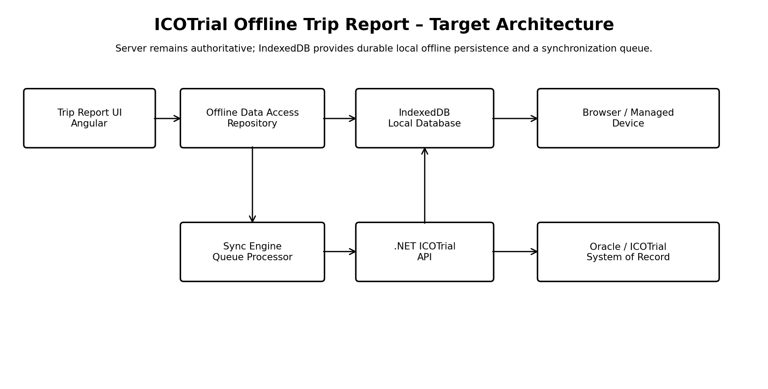
Figure 1 – Target logical architecture
Component | Role
Angular Trip Report UI | Authoring, validation, status indicators and user actions.
Offline Data Access / Repository | Single abstraction for local reads/writes; UI should not access IndexedDB directly.
IndexedDB | Local Trip Report, Master Data, sync metadata, queue and optional attachment storage.
Sync Engine | Processes pending operations, performs retries, handles acknowledgements and advances sync checkpoints.
.NET ICOTrial API | Authorization, validation, concurrency checks, idempotency and server persistence.
ICOTrial services | Business rules and orchestration.
Oracle | Authoritative persistent store / system of record.

5. Offline Trip Report User Journey
- User opens ICOTrial while online.
- Application validates session and checks IndexedDB schema version.
- Application obtains Master Data sync information and performs incremental or full synchronization.
- Required Trip Report context is downloaded and stored locally.
- User opens the Trip Report.
- If connectivity is lost, the application enters offline mode without discarding the local state.
- Every meaningful save is committed to IndexedDB first.
- A synchronization operation is created or updated in syncQueue.
- When connectivity returns, the Sync Engine submits pending operations.
- Server validates authorization, business rules and the client's base revision.
- Server commits the change and returns an acknowledgement and new server revision.
- Client marks the operation SYNCED only after acknowledgement.
- Conflicts and permanent failures remain visible until resolved according to business rules.

6. IndexedDB Design
Recommended object stores:
Store | Purpose | Suggested indexes
tripReports | Current local Trip Report aggregate | tripReportId, status, updatedAt
tripReportSections | Optional normalized sections | tripReportId, sectionId
masterData | Offline reference data | entityType, entityId, entityVersion, active
syncQueue | Pending and completed local operations | operationId, status, entityId, createdAt
syncMetadata | Global synchronization checkpoints | key
attachments | Optional offline binary data | attachmentId, tripReportId, uploadStatus
auditLocal | Optional local correlation events | auditId, tripReportId, operationId

6.1 Local-First Transaction Rule
When a user saves a Trip Report, the report state and its corresponding synchronization record should be committed in the same IndexedDB transaction wherever the chosen IndexedDB library permits. This prevents a report from becoming dirty without a queue entry.

6.2 Example Logical Record
TripReport: { tripReportId, status, payload, serverRevision, masterDataChangeId, updatedAt }
SyncOperation: { operationId, entityId, operation, baseRevision, status, retryCount, createdAt }

7. Master Data Versioning
Master Data freshness is central to a reliable offline Trip Report. The recommended design is a server-generated monotonically increasing Change ID. The client stores the last successfully applied Change ID in syncMetadata.
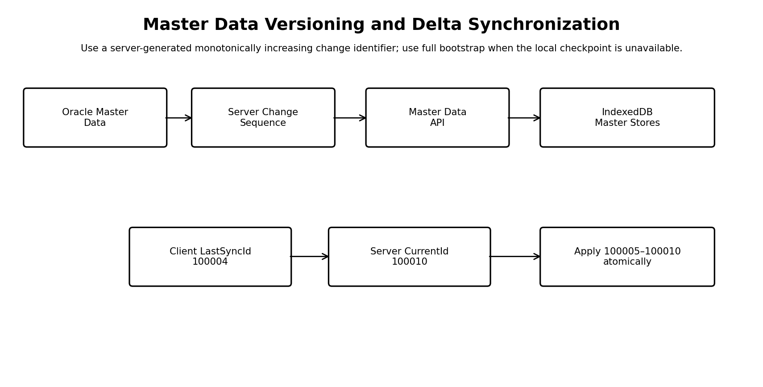
Figure 2 – Master Data versioning and delta synchronization
Metadata | Description
ChangeId | Global ordered change sequence generated by the server.
EntityType | Master entity category.
EntityId | Stable record identifier.
Operation | INSERT, UPDATE or DELETE.
EntityVersion | Optional per-entity revision.
ChangedAt | Server timestamp.
Payload/reference | Changed data or mechanism to retrieve current data.

7.1 Delta Sync
Example: client has lastSyncChangeId 100004 and server is at 100010. The client requests changes after 100004. The server returns 100005 through 100010. The client applies the complete batch atomically and only then advances lastSyncChangeId to 100010.

7.2 Delete Handling
Deletes must be explicit. A tombstone or DELETE event is required because returning only active records cannot tell the client whether a previously cached record was deleted or merely omitted.

7.3 Full Synchronization
- Perform full sync when IndexedDB is new or required stores are missing.
- Perform full sync when the client checkpoint is older than the server's available change history.
- Perform full sync when local integrity validation fails.
- After full sync, set the checkpoint only after all required data is committed successfully.

8. Trip Report Versioning and Concurrency
Master Data versioning and Trip Report concurrency are separate concerns. A Trip Report should carry a serverRevision (or equivalent optimistic concurrency token). The offline client sends the revision it last observed.
Condition | Expected result
Server revision equals client's base revision | Apply change; return new server revision.
Server revision differs | Return conflict; do not silently overwrite.
Same operationId already processed | Return the previous result; do not create a duplicate.
Report is already submitted/locked | Reject or route through the defined business workflow.
Referenced Master Data is retired | Apply approved business rule and surface if user action is required.

9. Synchronization Engine
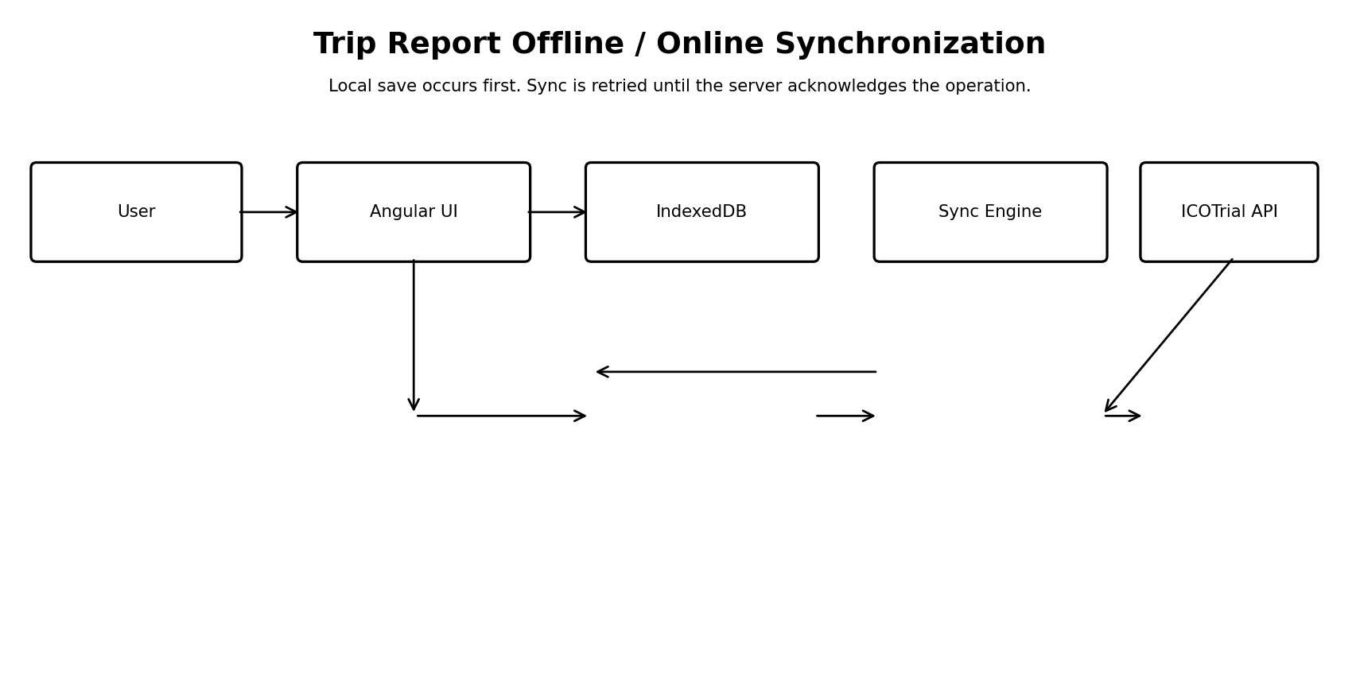
Figure 3 – Trip Report synchronization sequence

9.1 Queue States
State | Meaning
PENDING | Ready to synchronize.
IN_PROGRESS | Currently being transmitted.
RETRY | Temporary failure; eligible after backoff.
FAILED | Permanent/business failure requiring action.
CONFLICT | Server version differs from the offline base version.
SYNCED | Server acknowledgement received.
CANCELLED | Superseded or intentionally removed under an approved rule.

9.2 Idempotency
Each local operation must have a unique operationId. The server stores or otherwise recognizes processed operation IDs. If a client times out after the server commits, it can safely retry the same operationId and receive the original result rather than creating a duplicate.

10. Proposed API Contract
API | Purpose
GET /api/masterdata/sync-info | Return current server Change ID and sync capabilities.
GET /api/masterdata/changes?fromChangeId={id} | Return delta changes.
GET /api/tripreports/{id}/offline-package | Return Trip Report context and approved reference data.
POST /api/tripreports/sync | Submit one or more idempotent operations.
GET /api/sync/status/{operationId} | Recover status when a prior response is uncertain.
POST /api/tripreports/{id}/attachments | Upload approved offline attachments.
These endpoint names are proposed examples. They are not claimed to be existing ICOTrial APIs and must be finalized during API design.

11. Failure Handling and Recovery
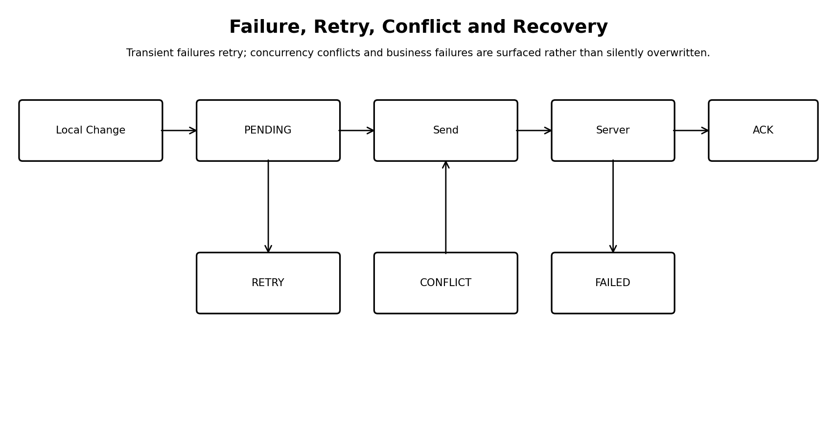
Figure 4 – Failure, retry, conflict and recovery
Failure | Handling
No network | Remain offline; keep local changes pending.
Timeout / HTTP 5xx | Retry with bounded exponential backoff and jitter.
401/403 | Pause synchronization and follow approved authentication/session recovery.
409 / concurrency conflict | Mark CONFLICT; require defined resolution.
Business validation error | Mark FAILED and show actionable error.
Response lost after server commit | Retry same operationId; server returns idempotent result.
IndexedDB unavailable | Do not claim offline readiness; enter controlled recovery mode.
IndexedDB cleared | Bootstrap local Master Data and Trip Report context again; unsynchronized local data cannot be reconstructed from the server unless the application has another recovery mechanism.
The uploaded AQ reference similarly defines retry, exception handling, recovery while a consumer is unavailable, and monitoring. It describes retaining messages while the consumer is unavailable and draining them after recovery. The browser implementation should apply the same reliability objective through its sync queue rather than assuming IndexedDB itself is a message broker. fileciteturn0file0L465-L509

12. Retry Policy
Attempt | Illustrative delay
1 | Immediate
2 | 1 minute
3 | 5 minutes
4 | 15 minutes
5 | 30 minutes
After maximum | Pause and surface failure / support alert
The exact retry policy should be configurable. The uploaded reference uses a similar bounded retry sequence and an exception queue after maximum attempts. fileciteturn0file0L552-L576

13. Security and Privacy
- Treat IndexedDB content as sensitive local application data.
- Do not store passwords or unnecessary long-lived authentication secrets in Trip Report stores.
- Use HTTPS/TLS for API communication.
- Minimize the offline dataset to what is required for the approved workflow.
- Define offline authentication and session-expiry behavior before implementation.
- Define behavior on sign-out when pending synchronization exists.
- Consider client-side application-layer encryption if required by security/compliance; IndexedDB itself is not an application encryption boundary.
- Apply an approved cleanup policy after successful synchronization/submission.
- Ensure server-side audit records remain authoritative.

14. Audit and Traceability
Attribute | Purpose
operationId | End-to-end correlation of one local change.
tripReportId | Business record identity.
actor/session | User and session context.
clientTimestamp | Time of local user action.
serverTimestamp | Authoritative processing time.
baseServerRevision | Revision edited by the client.
resultServerRevision | Revision produced by the server.
syncStatus | Processing outcome.
The AQ reference emphasizes transactional consistency between business data and event publication. For the Trip Report client, the analogous local rule is to atomically persist the business change and its synchronization operation, while the server remains the authoritative audit boundary. fileciteturn0file0L228-L246

15. Three Independent Version Concepts
Version | Example | Purpose
ICOTrial application version | 4.x.x | Controls application code/release.
IndexedDB schema version | 3 | Controls local database structure and migrations.
Master Data Change ID | 100010 | Controls data freshness and incremental synchronization.
Trip Report server revision | 8 | Controls optimistic concurrency for a business record.
These versions must not be conflated. A Master Data update should not require an application release, and an application release should not automatically imply that every Master Data record changed.

16. IndexedDB Schema Migration
- Open the database at the current application schema version.
- Run deterministic upgrade logic when the stored schema is older.
- Create new stores/indexes and transform existing records as required.
- Validate required stores and indexes.
- Preserve valid user drafts and pending operations.
- After migration, validate the Master Data checkpoint and synchronize as necessary.
- If migration fails, enter controlled recovery mode rather than silently deleting local data.

17. Connectivity Model
navigator.onLine should be treated only as a hint. The application should additionally perform a lightweight ICOTrial API connectivity check before starting synchronization. 'Network available', 'API reachable', 'session authorized' and 'operation successfully synced' are four different states.
State | Meaning
OFFLINE | Browser/network cannot reach the application service.
ONLINE_UNVERIFIED | Network appears available but API has not been verified.
ONLINE_AUTHENTICATED | API reachable and session is authorized.
SYNCING | Pending operations are being processed.
SYNCED | No pending changes for the selected scope.

18. Attachments
- Store attachment metadata separately from the Trip Report record.
- Use a checksum/hash to detect duplicate uploads.
- Track uploadStatus independently.
- Use controlled or resumable upload for large files if supported.
- Define file-type, size, retention and security scanning requirements.
- Do not mark a Trip Report fully synchronized if required attachments remain unsynchronized.

19. Local Data Retention and Cleanup
Local cleanup should be driven by an approved business/security policy, not simply by browser behavior. A safe baseline is to retain pending and conflicted data until resolved. After successful server synchronization and completion of the relevant business lifecycle, the application may delete or compact local data according to approved retention rules.
Data | Suggested policy
Pending Trip Report | Retain until synced or explicitly resolved.
Conflict | Retain until resolved.
Synced draft | Retain only for the approved local retention period.
Submitted/locked report | Apply business-approved cleanup.
Master Data | Refresh continuously while online; remove obsolete data during controlled sync.
Attachments | Remove only after successful upload and approved retention decision.

20. Performance Considerations
- Use IndexedDB indexes for Trip Report ID, status and updatedAt.
- Batch Master Data delta changes.
- Apply each delta batch transactionally.
- Avoid duplicating large JSON payloads across stores.
- Keep large binary attachments outside the main report object.
- Measure startup sync duration and local query performance on supported enterprise devices.
- Set practical limits for offline package size.

21. Monitoring and Operational Support
The reference AQ architecture monitors queue depth, oldest unprocessed message, throughput, failed messages, exception queue size, latency and retry count. Equivalent metrics should be defined for the ICOTrial client/server synchronization service. fileciteturn0file0L578-L610
Metric | Why it matters
Pending operation count | Shows client backlog.
Oldest pending age | Detects stalled synchronization.
Sync failure rate | Detects service or data-quality problems.
Conflict count | Shows concurrency/business workflow issues.
Master Data lag | Identifies stale offline reference data.
Full-sync frequency | Can indicate storage loss or migration problems.
Average sync latency | Measures user experience.
Attachment failure rate | Detects large-file/network problems.

22. Testing Strategy
Area | Key scenarios
Offline workflow | Create/edit/save/reopen after browser restart.
Reconnect | Network drops and returns during sync.
Idempotency | Same operation sent multiple times.
Concurrency | Server record changes while client is offline.
Master Data | Insert/update/delete and delta checkpoint recovery.
Full sync | Empty database, old checkpoint and missing stores.
Storage | User clears site data; storage pressure; private mode.
Migration | Upgrade from previous IndexedDB schema.
Security | Session expiry, logout, unauthorized access assumptions.
Attachments | Interrupted upload, duplicate file, large file.
Performance | Large report, large Master Data set, many pending operations.

23. Rollout Plan
- Prototype one Trip Report section with IndexedDB local-first persistence.
- Validate offline save/reopen and schema migration.
- Implement Master Data Change ID and delta synchronization.
- Implement one end-to-end Trip Report sync operation with idempotency.
- Add optimistic concurrency and conflict UX.
- Add operational telemetry and support dashboards.
- Pilot with controlled users/devices.
- Complete security, compliance and performance review.
- Expand to the full Trip Report scope and attachments.

24. Key Risks and Mitigations
Risk | Mitigation
Browser storage cleared/evicted | Clear offline status, full bootstrap recovery; minimize unsynchronized time.
Stale Master Data | Server Change ID + delta sync + pre-offline validation.
Duplicate submission | operationId and server idempotency.
Silent data overwrite | Optimistic concurrency and conflict state.
Large offline package | Scope data to required Trip Report context; batch Master Data.
Session expiry offline | Define explicit offline authentication/session model.
Attachment loss | Separate attachment queue, checksum and upload acknowledgement.
Schema change | IndexedDB schema versioning and tested migrations.
Unobservable failures | Client/server sync telemetry and alerts.

25. Architecture Decision Summary
Decision | Approach
Local persistence | IndexedDB
Architecture style | Offline-first / local-first
System of record | ICOTrial server / Oracle
Master freshness | Server Change ID + entity version
Trip concurrency | Server revision / optimistic concurrency
Duplicate protection | operationId + server idempotency
Deletes | Explicit delete/tombstone changes
Recovery | Incremental sync; full bootstrap when checkpoint is unavailable
Retry | Bounded exponential backoff
Audit | Server authoritative audit + operation correlation
Attachments | Separate local queue and controlled upload
Cleanup | Business/security-approved local retention policy

26. Open Decisions for Architecture Review
- What Trip Report fields are allowed to be stored offline?
- What Master Data is required offline and what is its maximum acceptable age?
- What is the approved offline authentication duration?
- What happens if a user signs out with pending changes?
- What is the official conflict-resolution workflow?
- What local retention period is required?
- Are attachments permitted offline?
- Which enterprise browsers and versions are supported?
- Should synchronization be REST-based only, or is an enterprise event/queue component required on the server side?
- What are the final ICOTrial API and Oracle transaction boundaries?

27. Conclusion
IndexedDB is a suitable browser-side persistence mechanism for an ICOTrial offline Trip Report capability when combined with a disciplined synchronization architecture. The critical design is not IndexedDB alone; it is the combination of local-first persistence, deterministic Master Data versioning, idempotent server processing, optimistic concurrency, retry/recovery and auditability.
The recommended implementation keeps the server authoritative and uses IndexedDB as a recoverable local replica/work queue. Master Data should be synchronized using a server-generated change sequence, while Trip Reports should use server revisions to detect concurrent edits. This provides a clear foundation for a production-grade offline workflow and allows the application to recover predictably from network failures, browser restarts, storage loss and application upgrades.

Appendix A – Illustrative Data Structures
interface TripReport {
tripReportId: string;
status: 'DRAFT' | 'PENDING_SYNC' | 'SYNCED' | 'CONFLICT' | 'FAILED';
serverRevision?: number;
masterDataChangeId: number;
payload: unknown;
updatedAt: string;
}
interface SyncOperation {
operationId: string;
entityType: 'TripReport' | 'Attachment';
entityId: string;
operation: 'CREATE' | 'UPDATE' | 'DELETE';
baseServerRevision?: number;
status: 'PENDING' | 'IN_PROGRESS' | 'RETRY' | 'FAILED' | 'CONFLICT' | 'SYNCED';
retryCount: number;
createdAt: string;
lastAttemptAt?: string;
}

Appendix B – Reference to Uploaded Oracle AQ Design
The uploaded Oracle AQ design describes a two-phase pattern: an initial full load followed by delta synchronization using database triggers and AQ messages. It also describes acknowledgement, retry, exception handling, recovery and retention/cleanup. fileciteturn0file0L17-L51
For this document, those concepts are used only as reliability and synchronization design references. The proposed browser design does not claim that Oracle AQ is currently part of ICOTrial Trip Report processing.

